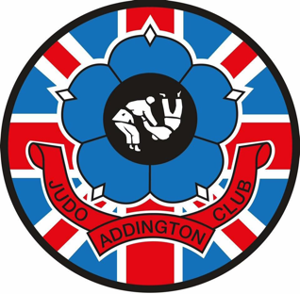
Updated January 15th, 2026,

PAYMENTS FOR SESSIONS: important, please read
We are currently still having issues with people NOT paying their Subs for the month ON TIME, this must be done either by Bank Transfer before the first session of the month or Cash ON the first session, in future if this is not adhered to your child/Student may not be able to attend the session after payment is due, PAYG is the other option but must be paid before the student goes on the mat!!

MERCHANDISE SHOP: Support the Brand,
Students should wear either a PLAIN WHITE Tee Shirt or a BLACK or WHITE Club Rash Guard under their Judo Jacket, these should be Round or V Neck NOT POLO (no buttons) we have many in kids and adults’ sizes at present,
We also have hoodies, joggers, leggings and compression shorts, please see the catalogue for prices.
Judo club badges are in stock it would be great for those representing the club to have these sewn on their jackets, these are still at only £3 each and can be picked up from the signing in desk.

……Upcoming events.

28th Feb, The North London Open, £20, HP12 4UE Competition experience is a must.

Addington Judo Club.

.

