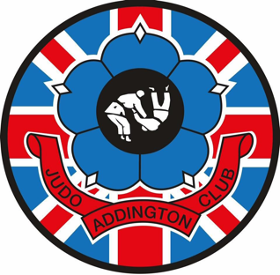
Updated June 18th, 2026,

MASSIVE CONGRATS:
To Conrad on his first MMA fight and win by armlock, very proud matey.

AND…
The walkers in the procession at the New Addington Carnival, we won again….
Next year we want a much bigger number walking around though.

……Upcoming events.

12th July, Shizentai Rumble, all ages and ability, £20, AL10 9EU, Novice (first competition) entries included and all the way to black belt.

Yours, in Judo,

Addington Judo Club.

.

AJC April Grading.

The next grading will be held throughout April, beginning on the 2nd of April and finishing on the 30th. Grades will be awarded no earlier than April 28th.

The cost of the grading will be £4.00 payable at the start of the month, you must hand your licence in to the main table when you register (at the start of the month) if it expires on or before 30th of April, it must be renewed costing £27 (under 18’s) £33 (over 18’s), A full licence must be in effect for over a month before a grading can be carried out.

All those expecting to grade MUST have their own Judogi (suit), if required see sensei Steve.

If juniors/Seniors are to be graded to a new colour belt this will be provided by the club as part of the Grading fee.

The club reserves the right to defer or postpone a grading if the judoka has not shown good enough attendance and/or quality in their judo.

Any queries, please speak with Sensei Steve or Sensei Gareth.

