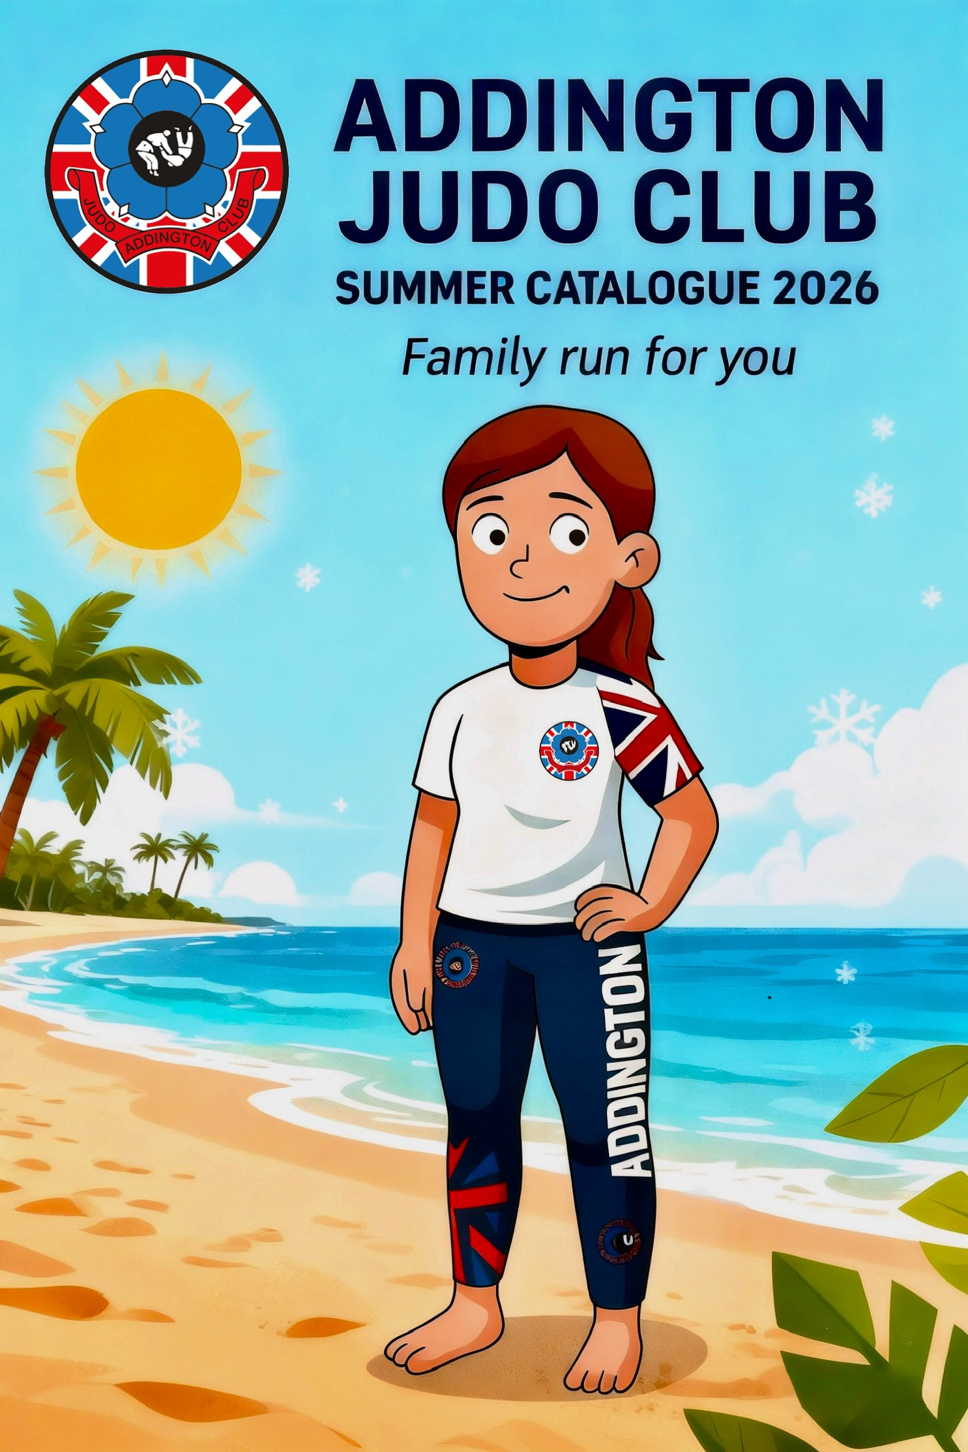
Contents

3. AJC Judogi - £55
4. Kit Bags - £30
5. Hoodies - £20
6. Jogging Bottoms - £20
7. MMA Shorts - £20
8. Long Sleeved Rash Guards - £20
9. Short Sleeved Rash Guards - £18
10. Leggings/Yoga Pants - £18
11. Vale Tudo Compression Shorts - £16
12. Tee Shirts - £15
13. Shorts - £15
14. Bobble Hats - £15
15. Baseball Caps - £10
16. Embroidered Badges - £3
17. Pin Badges - £3
18. Head bands - £2
19. Bumper stickers - £1

AJC Judogi (Judo suits)
Sizes – 160cm, 170cm, 180cm, 190cm,200cm.

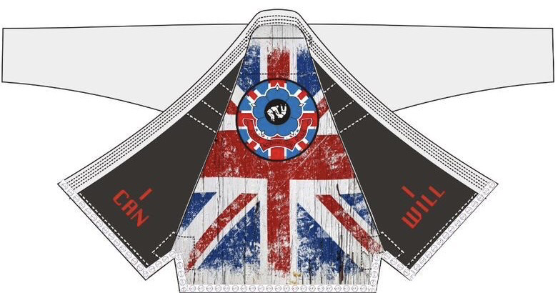
£55
750GSM Suit with / without Inner lining.

Must be ordered in batches of 10 min.

Kit Bags
Size – Large
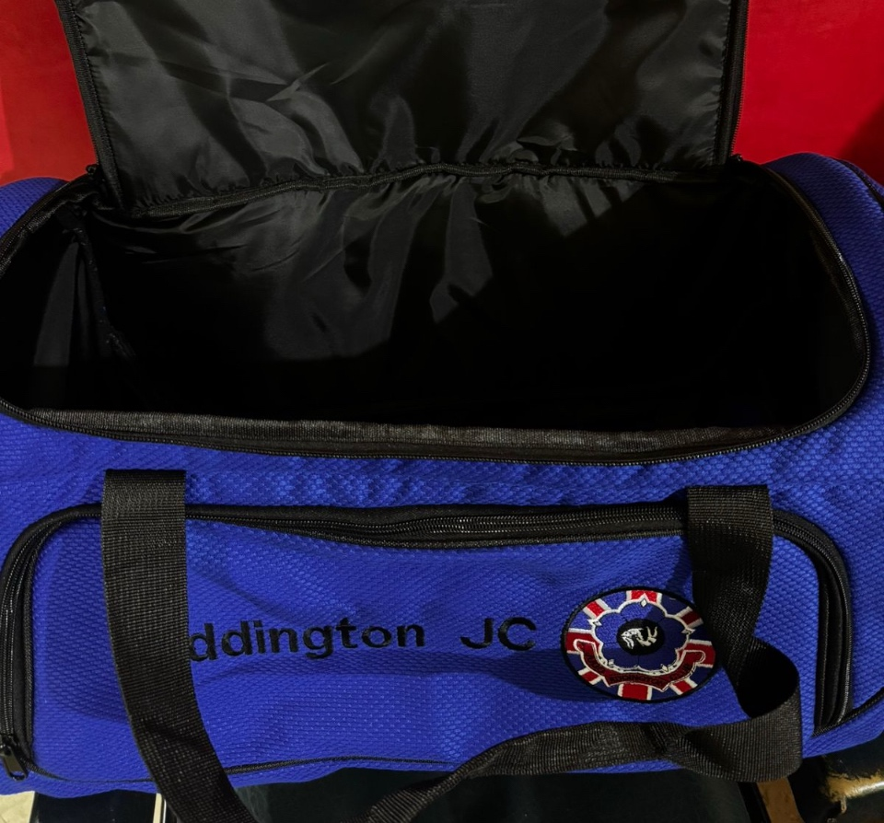
Blue only.

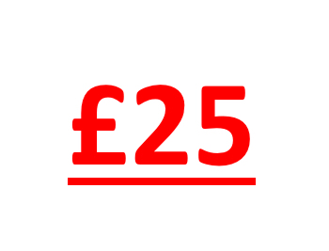
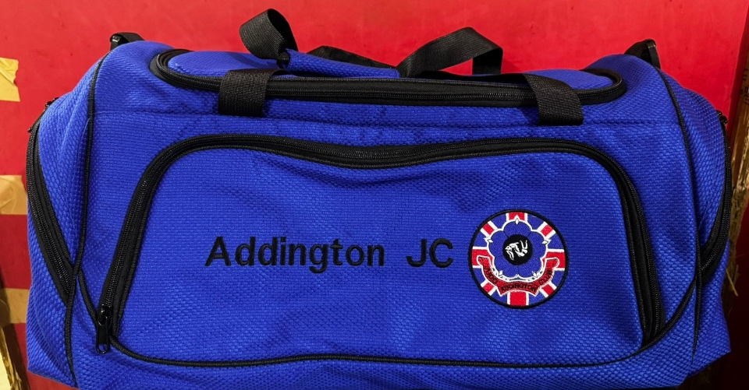

Hoodies
Sizes – 8-9, 9-10, 11-12, XS, S, M, L, XL, XXL, XXXL

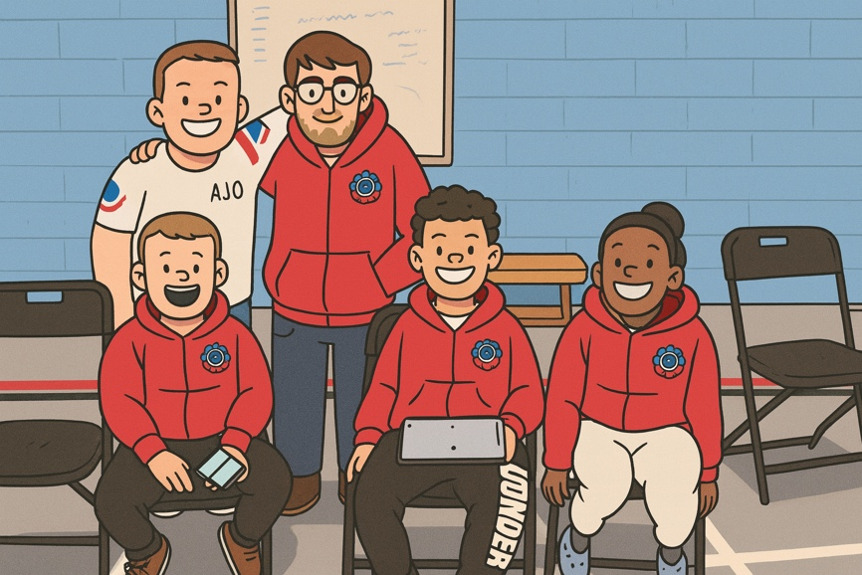
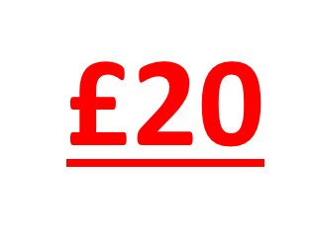
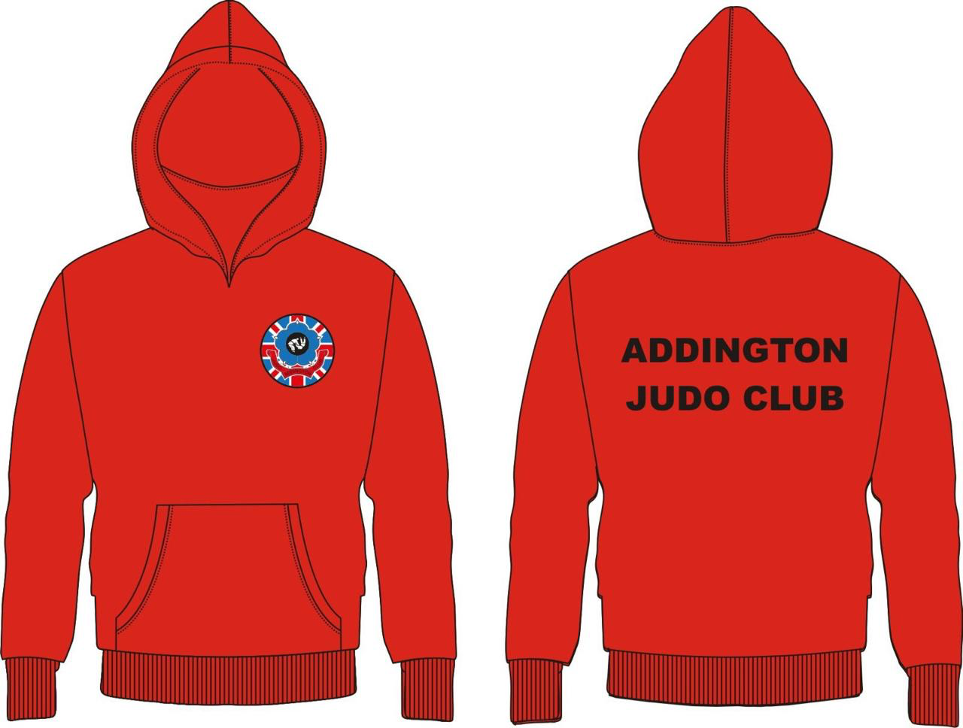

Jogging Bottoms
Sizes – 8-9, 9-10, 11-12, XS, S, M, L, XL, XXL, XXXL
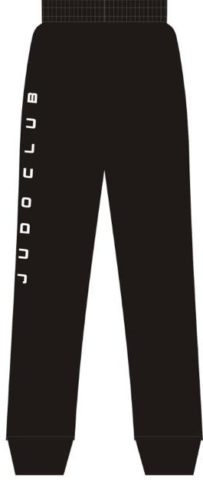
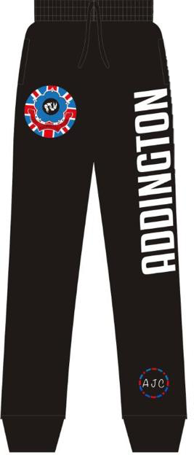
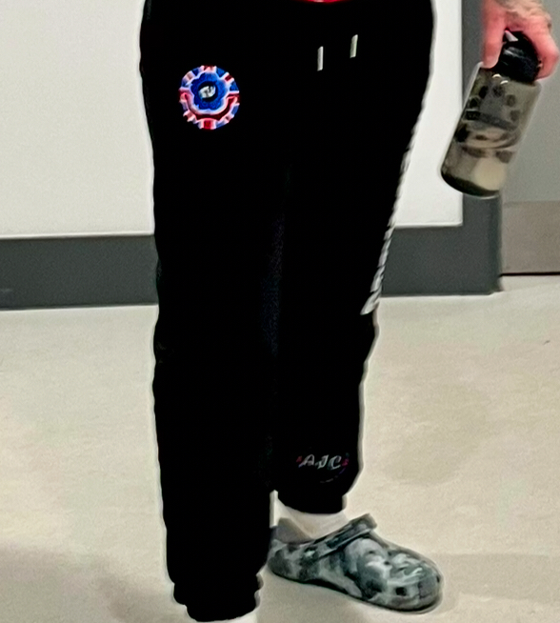

MMA Shorts
Sizes, S, M, L XL,

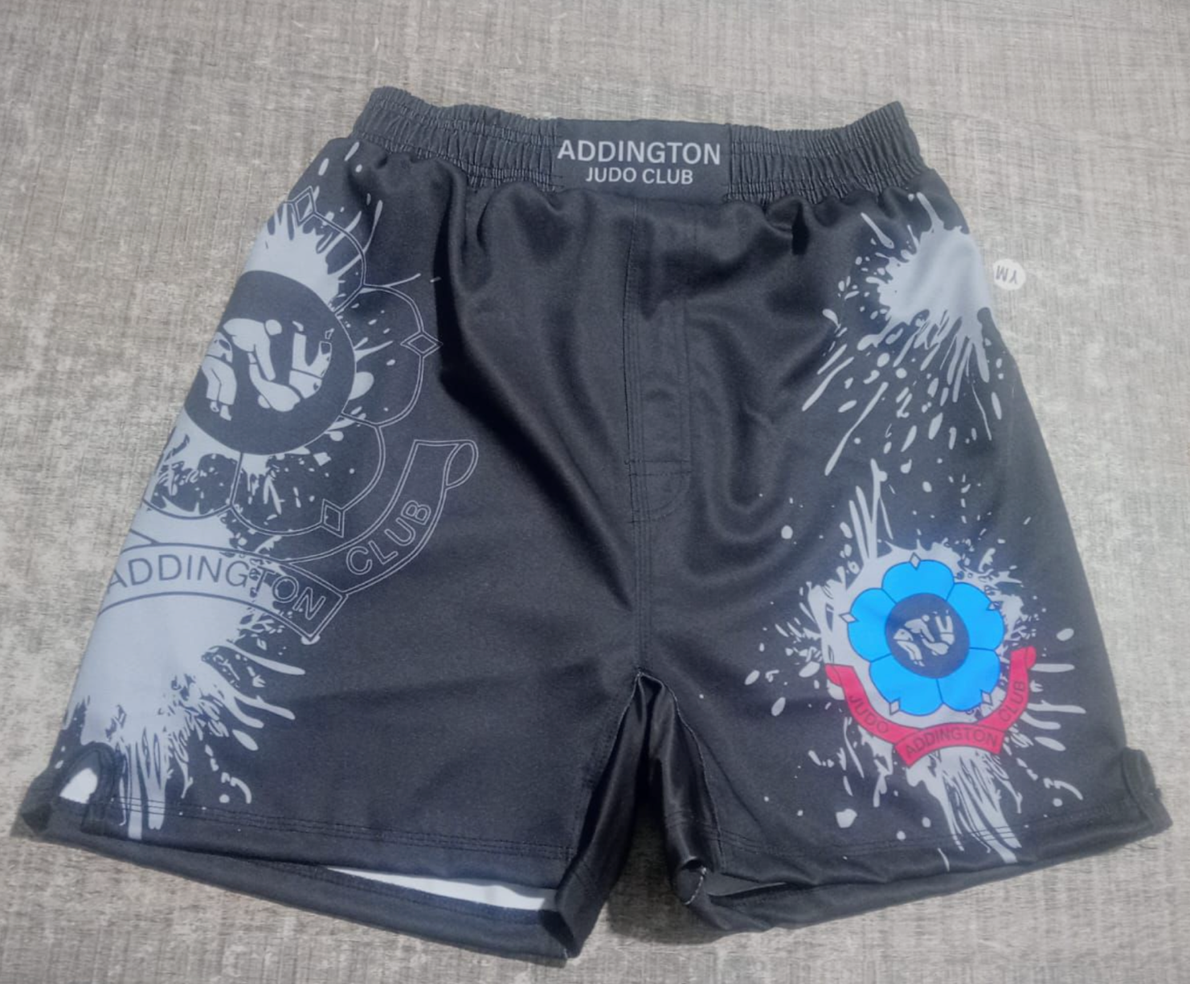

Long Sleeved Rash Guards
Sizes – XS, S, M, L, XL, XXL, XXXL
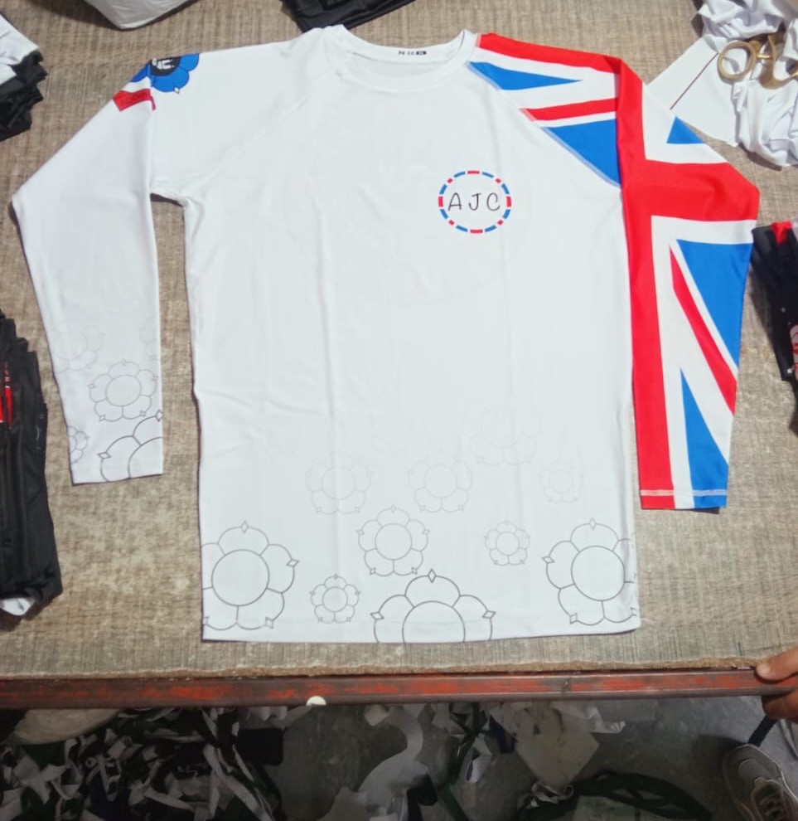
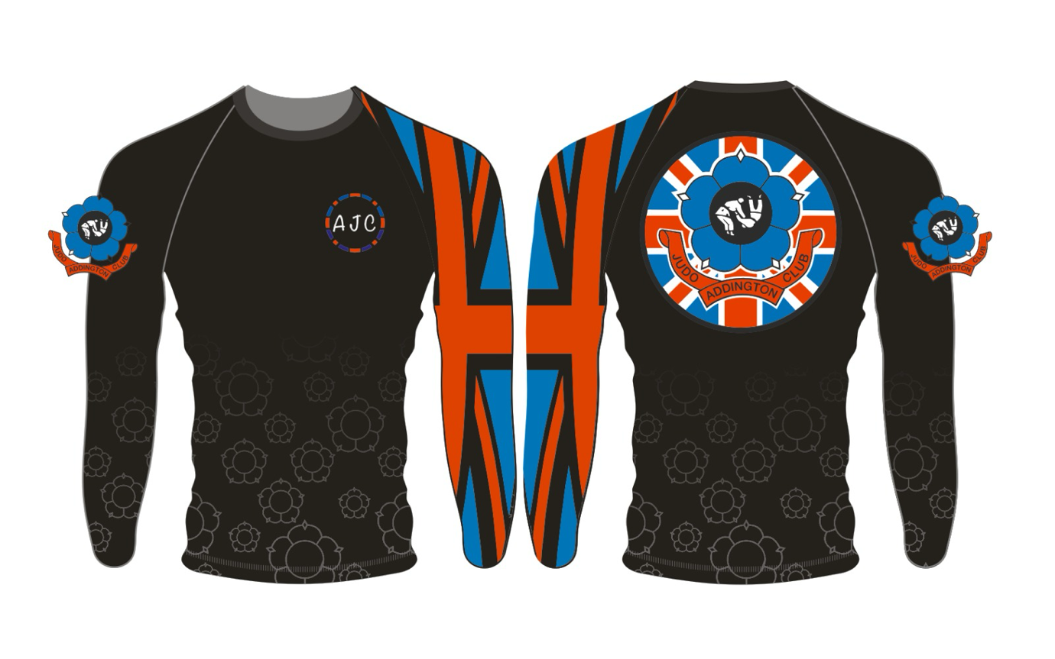
White or Black.

Short Sleeved Rash Guards
Sizes – 6-7, 8-9, 9-10, 11-12, XS, S, M, L, XL, XXL, XXXL
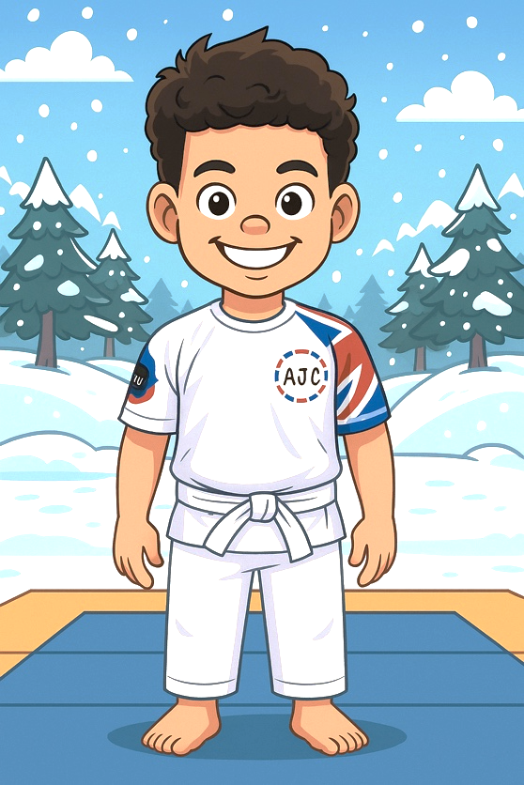
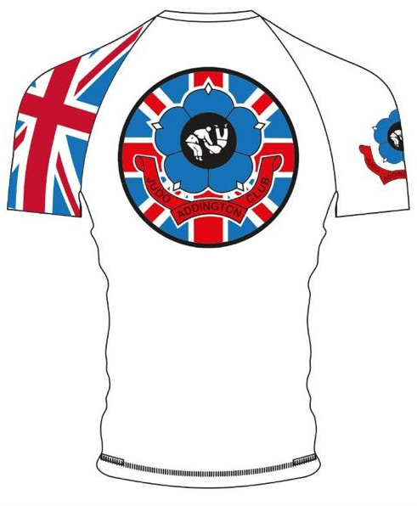
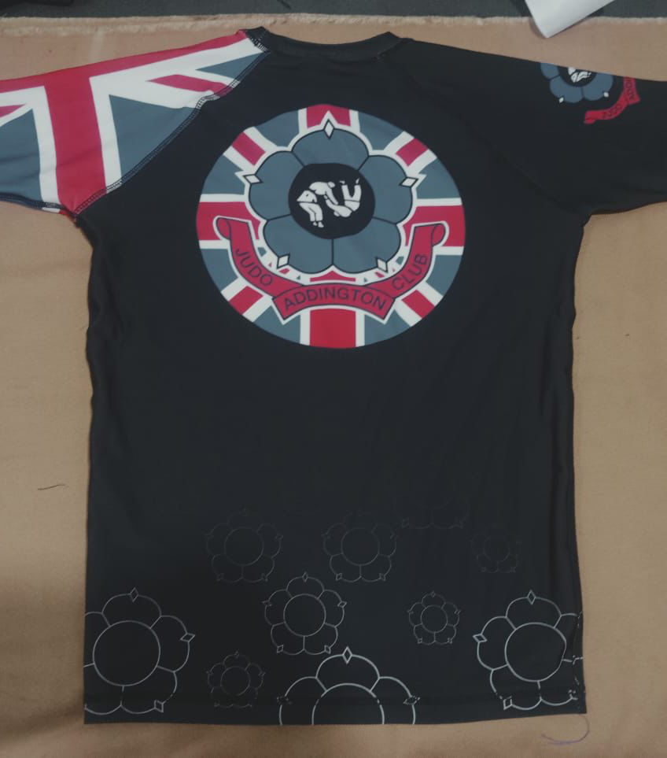
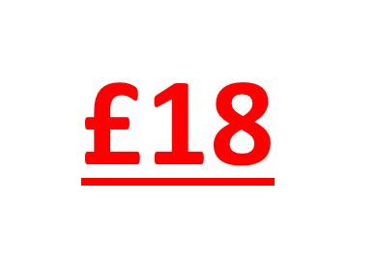
White or Black

Leggings/ Yoga Pants
Sizes – 8-9, 9-10, 11-12, XS, S, M, L, XL,
Black Only.
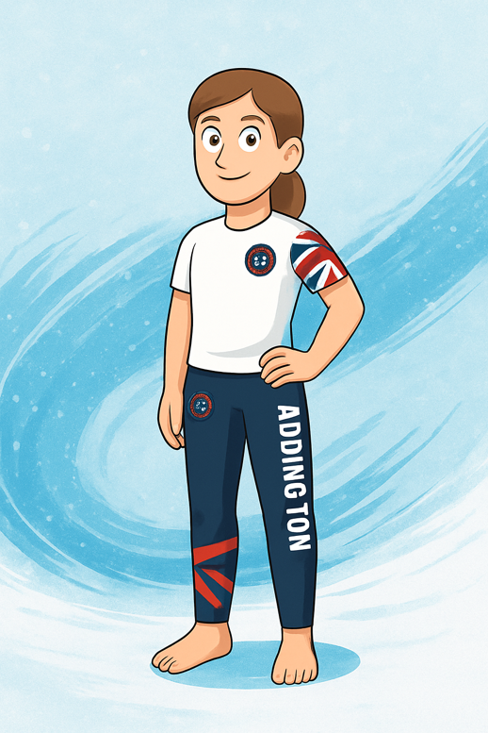
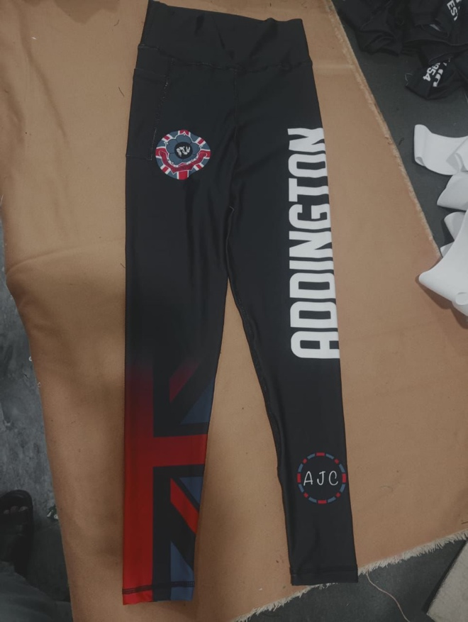

Vale Tudo Compression Shorts
Sizes – 8-9, 9-10, 11-12, XS, S, M, L, XL,
Black Only.
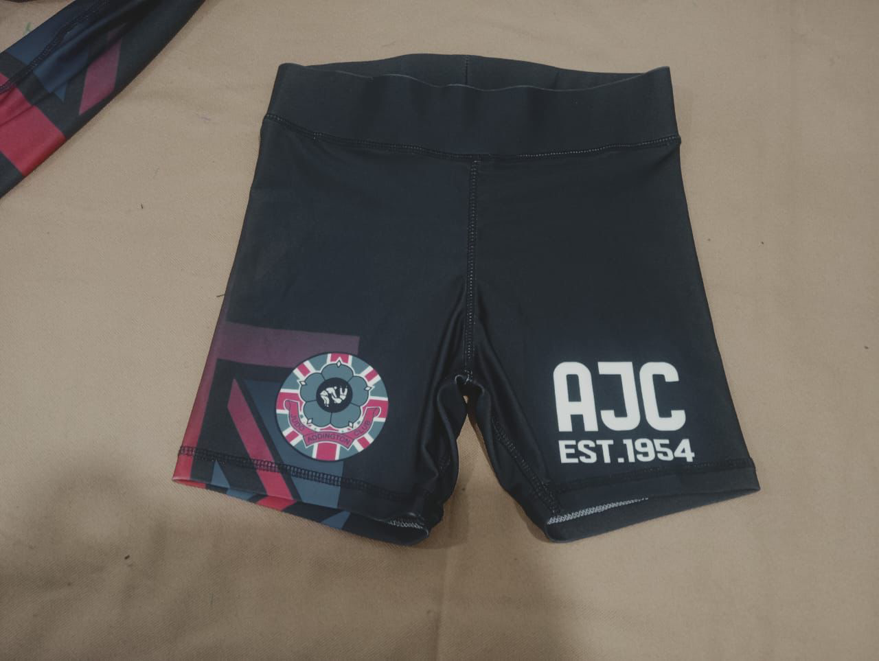
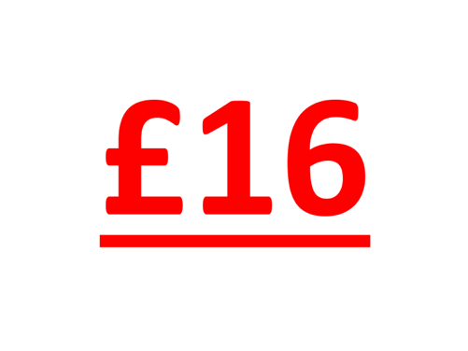

Tee Shirts
Sizes – 8-9, 9-10, 11-12, XS, S, M, L, XL, XXL, XXXL
Polo/Round-neck
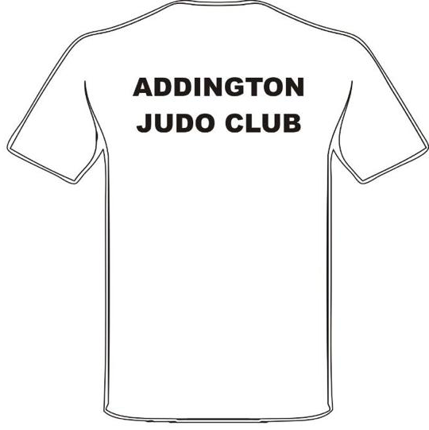
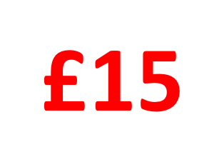
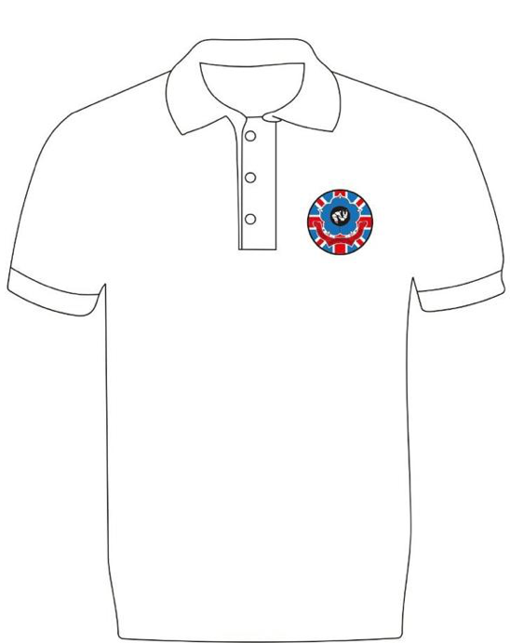
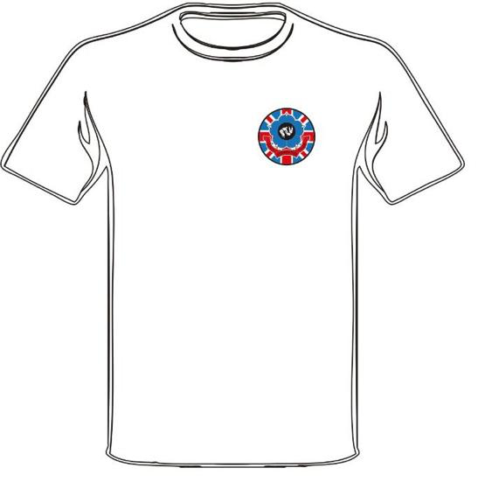
White only.

Shorts.
Sizes – XS, S, M, L, XL, XXL, XXXL
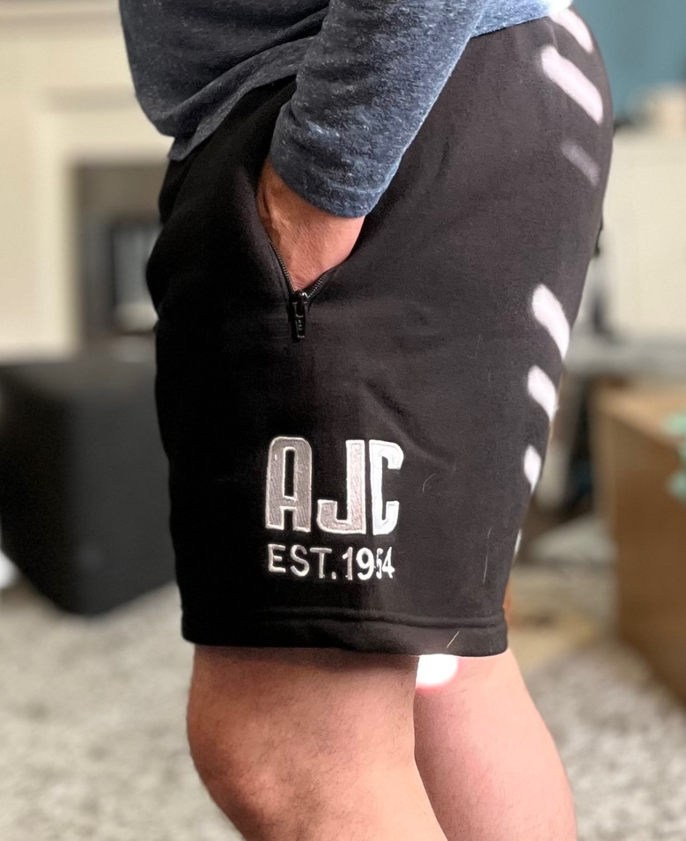
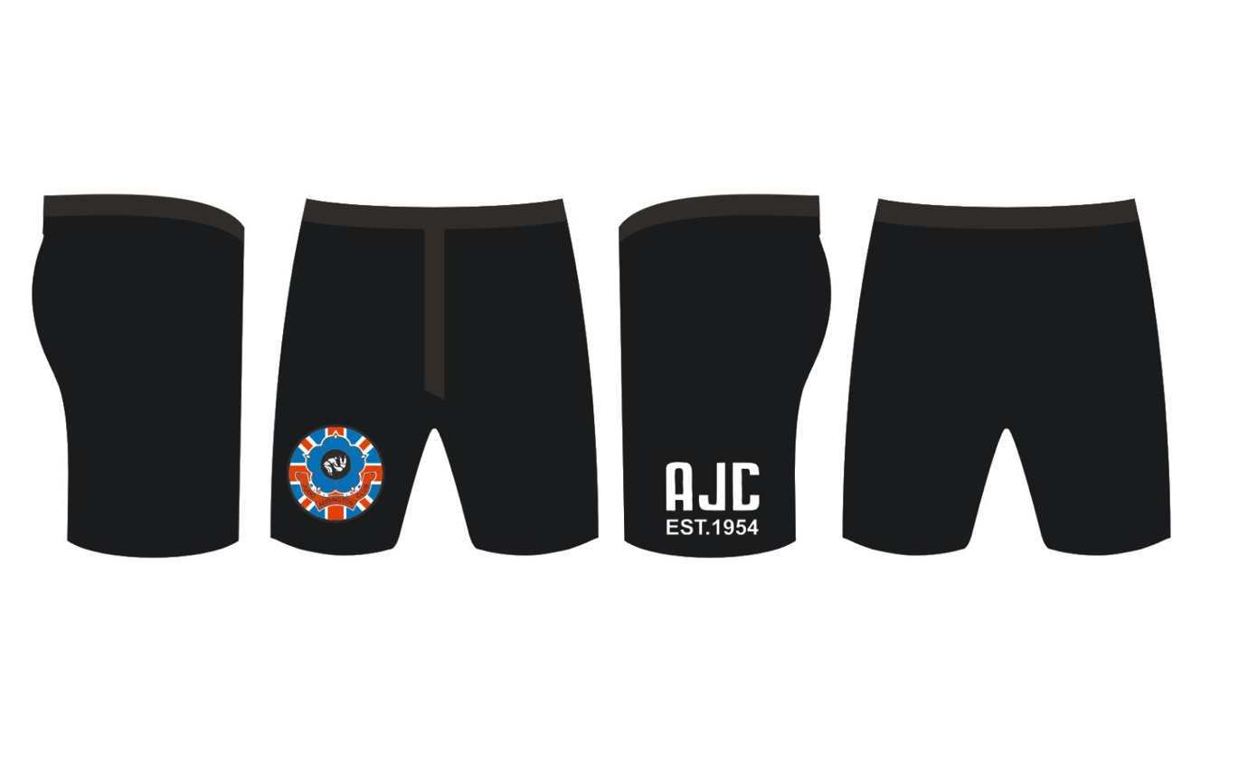
Black only.

Bobble Hats
Sizes – One size fits all.

Black only (with Red Bobble).
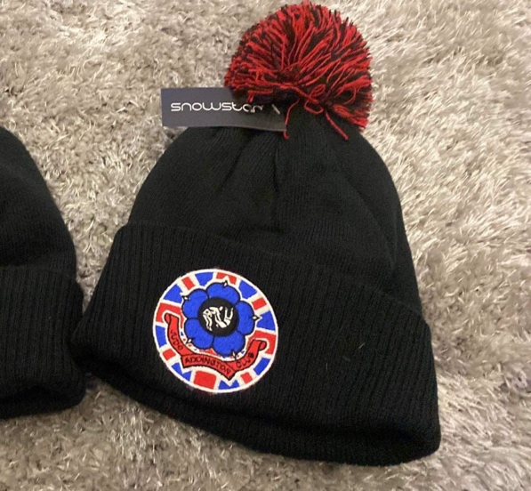

Baseball Caps
Sizes – One size fits all.
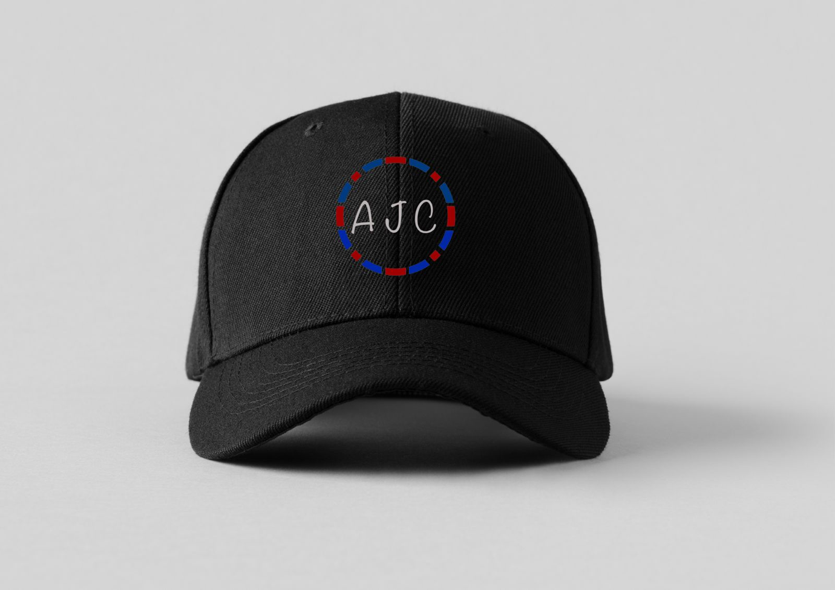
Black or Grey.
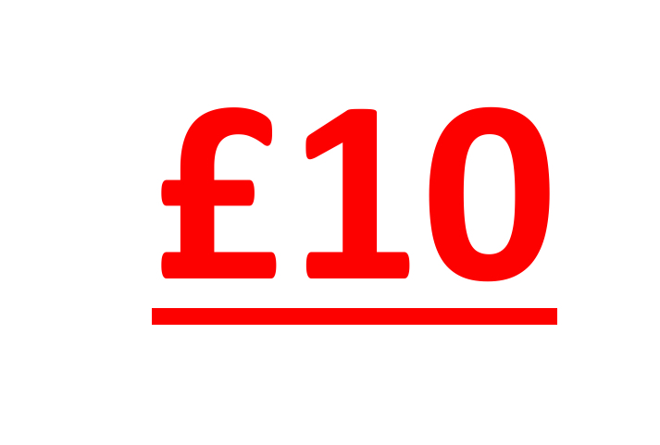
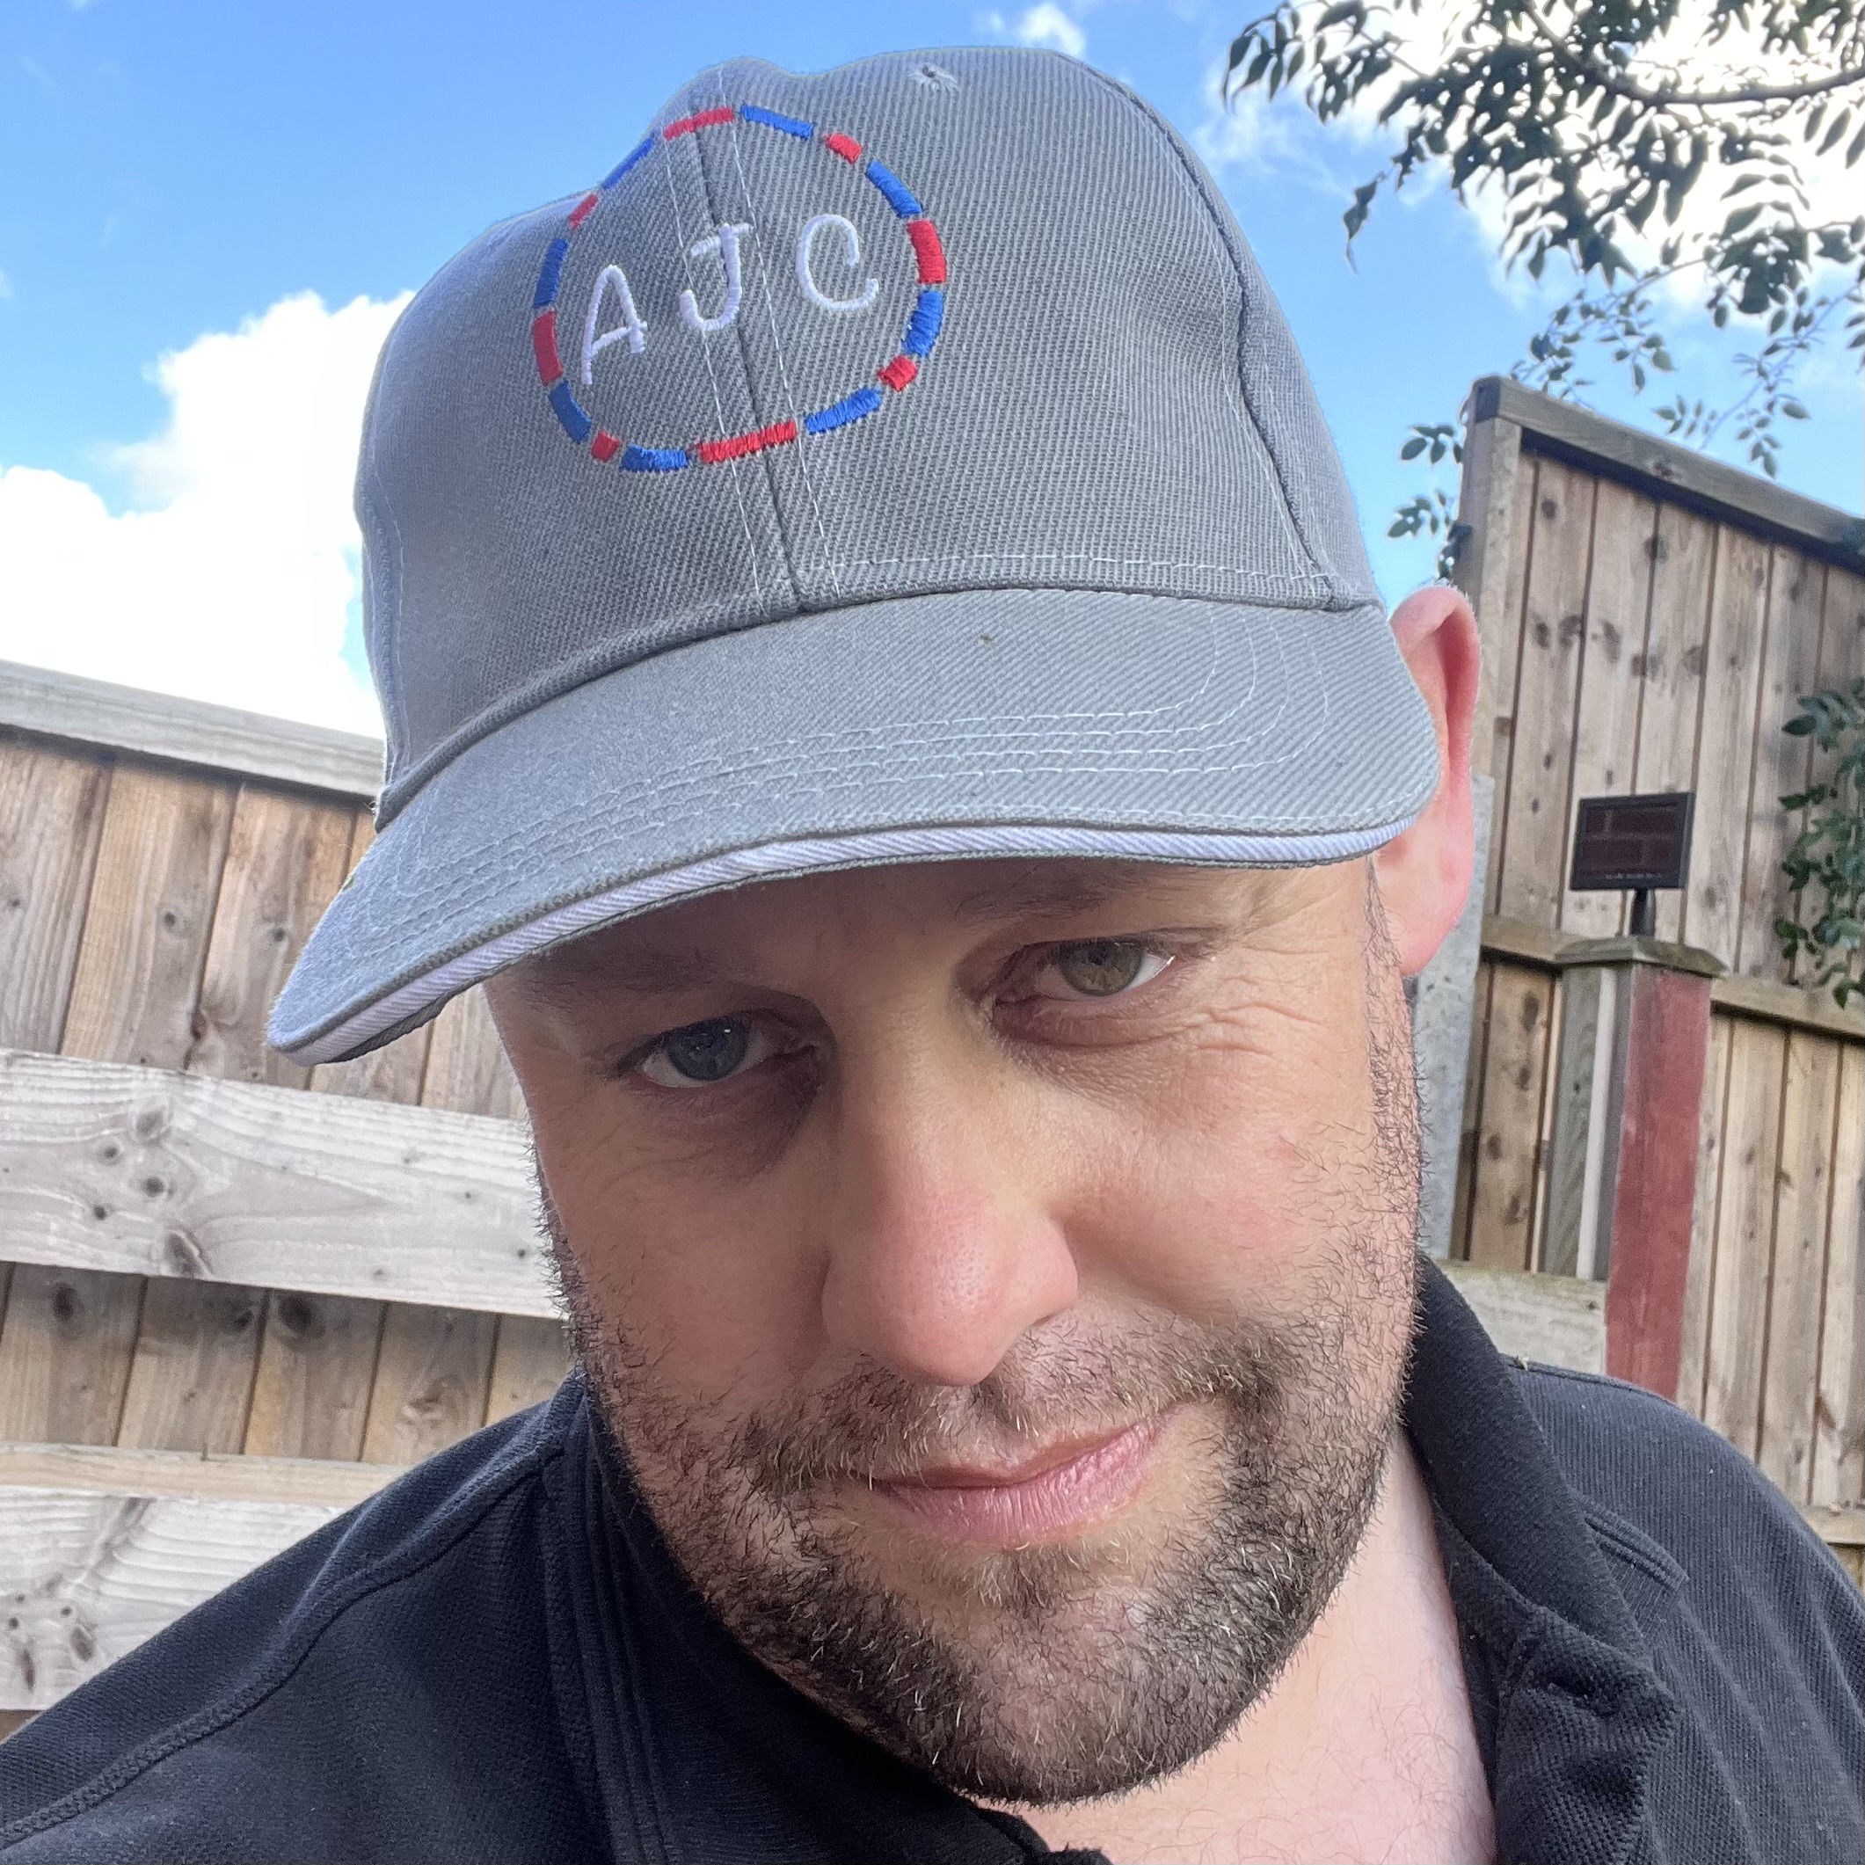

Embroidered Badges
Size – 3.5 Inch
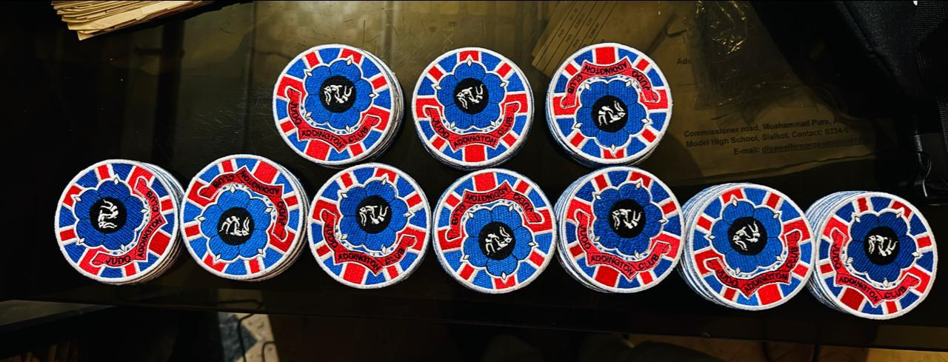
£3.00

Sewn on the bottom part if the judogi jacket.

Pin Badges
Size – 1 Inch
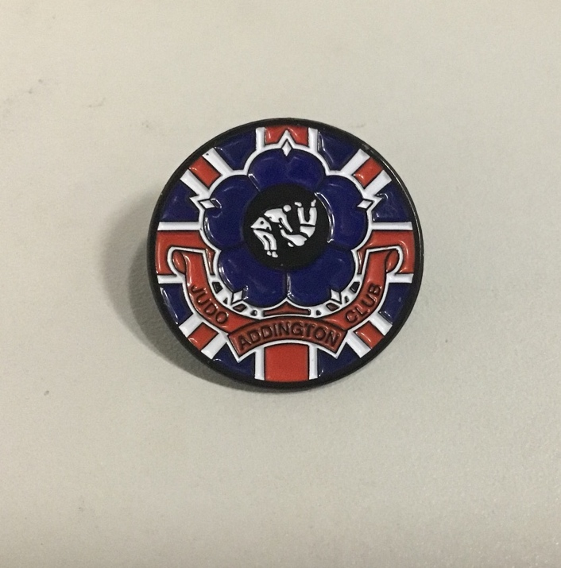
£3.00

For wearing on Referees suits/parents/students clothes (not Judogi)

Carnival Headbands
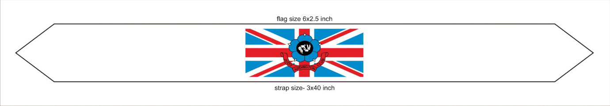
Sizes - One size fits all.
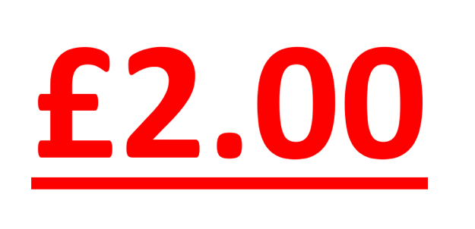

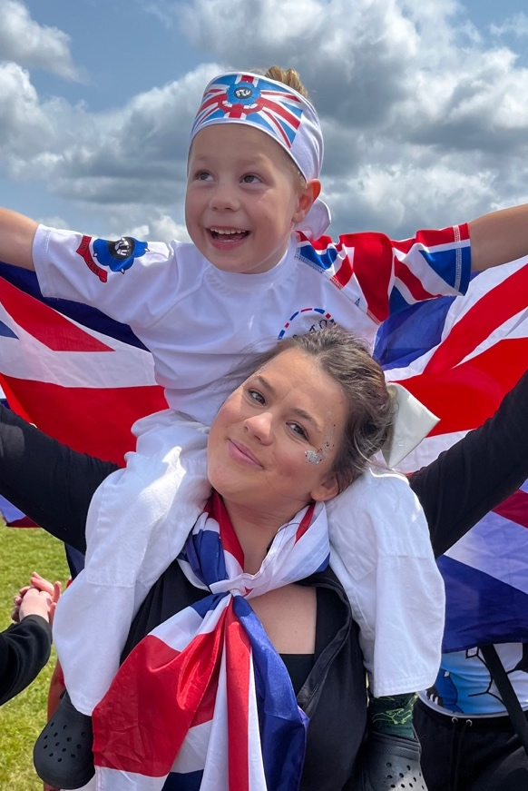

Bumper Stickers
For the car or a drinks bottle even.
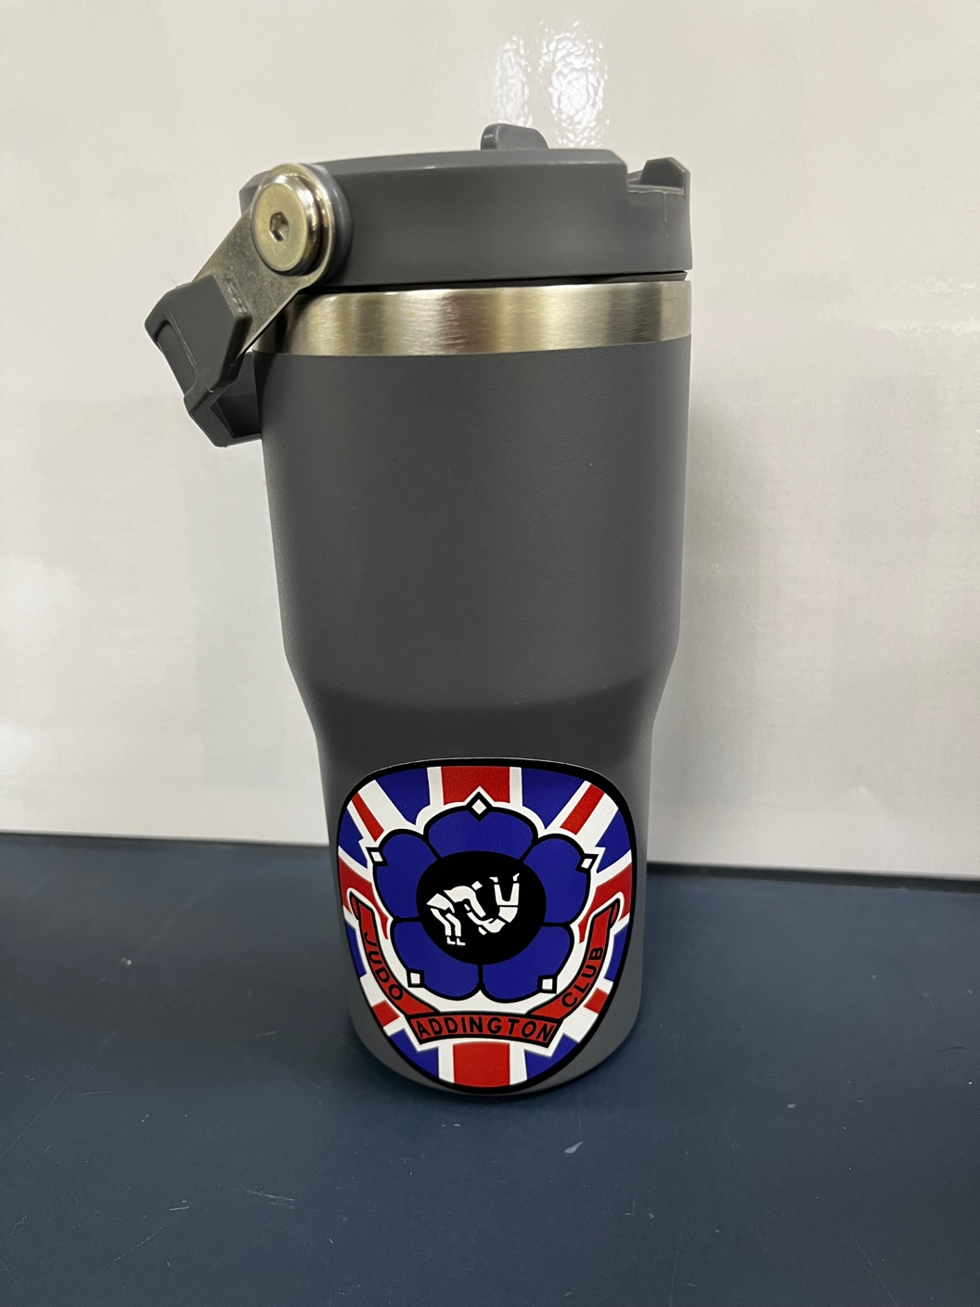
£1.00

