Addington Judo Club Newsletter.

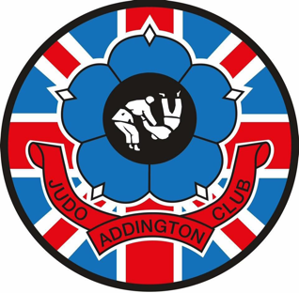
Updated November 25th, 2025,

What can I say, we are now officially over 100 Judoka at the club and I couldn’t be prouder of where we have come,

We are currently still having issues with people paying their Subs for the month, this must be done either by Bank Transfer before the first session of the month or Cash ON the first session, in future if this is not adhered to your child/Student may not be able to attend the session after payment is due, PAYG is the other option but must be paid before the student goes on the mat.

The Xmas party and awards night is well within our radar now, this will be held in the Fieldway Centre opposite Wayside Shops from 7pm on the 18th of December (Thursday), it is free to come along, bring whatever drink you require and a dish for the Buffet (we will bring out a list for you to allocate what you wish to bring along so not all people bring sausage rolls)

The last proper judo night is Tuesday the 16th (any students having paid monthly can move their Thursday night forward to this for no extra charge)
We return on Tuesday, January 6th, 2026.

Judo club badges are in stock it would be great for those representing the club to have these sewn on their jackets, these are still at only £3 each and can be picked up from the signing in desk.

……Upcoming events.

A well deserved break……. see you in January.

Addington Judo Club.



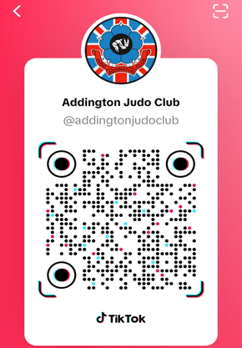

AJC TikTok. BJC TikTok. AJC NewsWhatsApp.

